Usig the lm( )-function in R fit the 2-factor-model of the first lecture in linear

modelling:

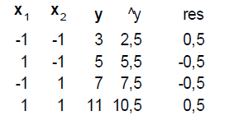

Calculate coefficients, predictions, residuals for the linear model.

Then calculate coeffients for the interaction model.

What happens if you change x values to 20 instead of -1 and 40 instead of +1 for x1

and to 20 instead of -1 and 30 instead of +1 for x2?

Have the coefficients changed? Have the predictions changed?